12 July 2023, Rudolf

Running Streamlit on MacBook Pro

processing GUVs: guv1.h5, guv2.h5, guv3.h5, guv4.h5 generated using Mathematica code in BirefrObjectGeneratorJuly2023.nb.

**Optical settings:**

Number of microlenses: 7

Pixels per microlens: 17

Number of voxels per microlens (supersampling): 1

Magnification: 60

NA of objective: 1.2

Wavelength of light: 0.55 µm

camera pixel size: 6.5 µm

refractive index of medium: oil n=1.35

**Forward Projection:**

**guv1_GT.h5 -> guvBir[radius=3.5, membrane thickness=1, Δn=0.01]**

single voxel deep slice through center of GUV

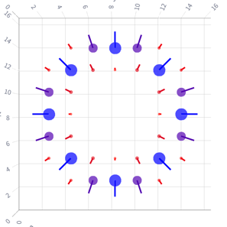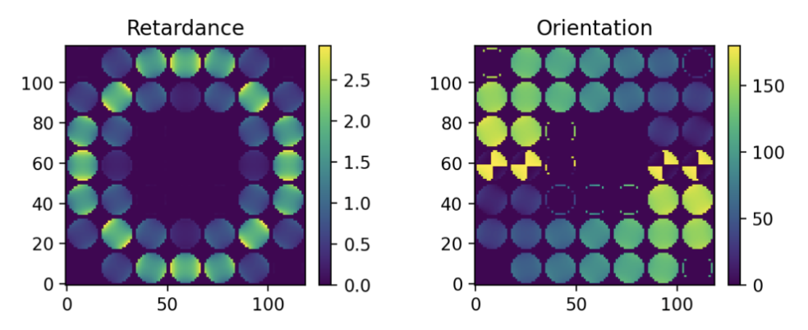

When forward projecting guv1_GT.h5 using the Mathematica Notebook PolRayTraceBirefrImagingJuly2023.nb, the maximum retardance is 1.45radian

**Reconstruction in May:**

Iteration 50

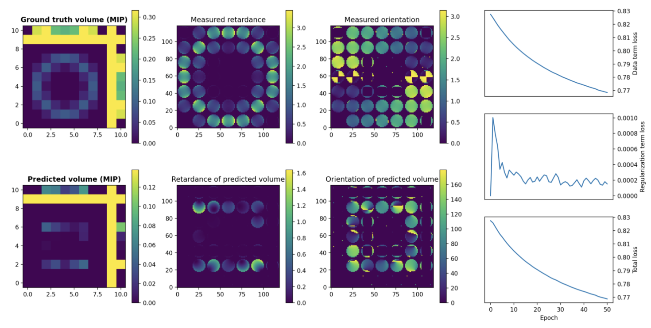

**Reconstruction in July (200 iterations)**

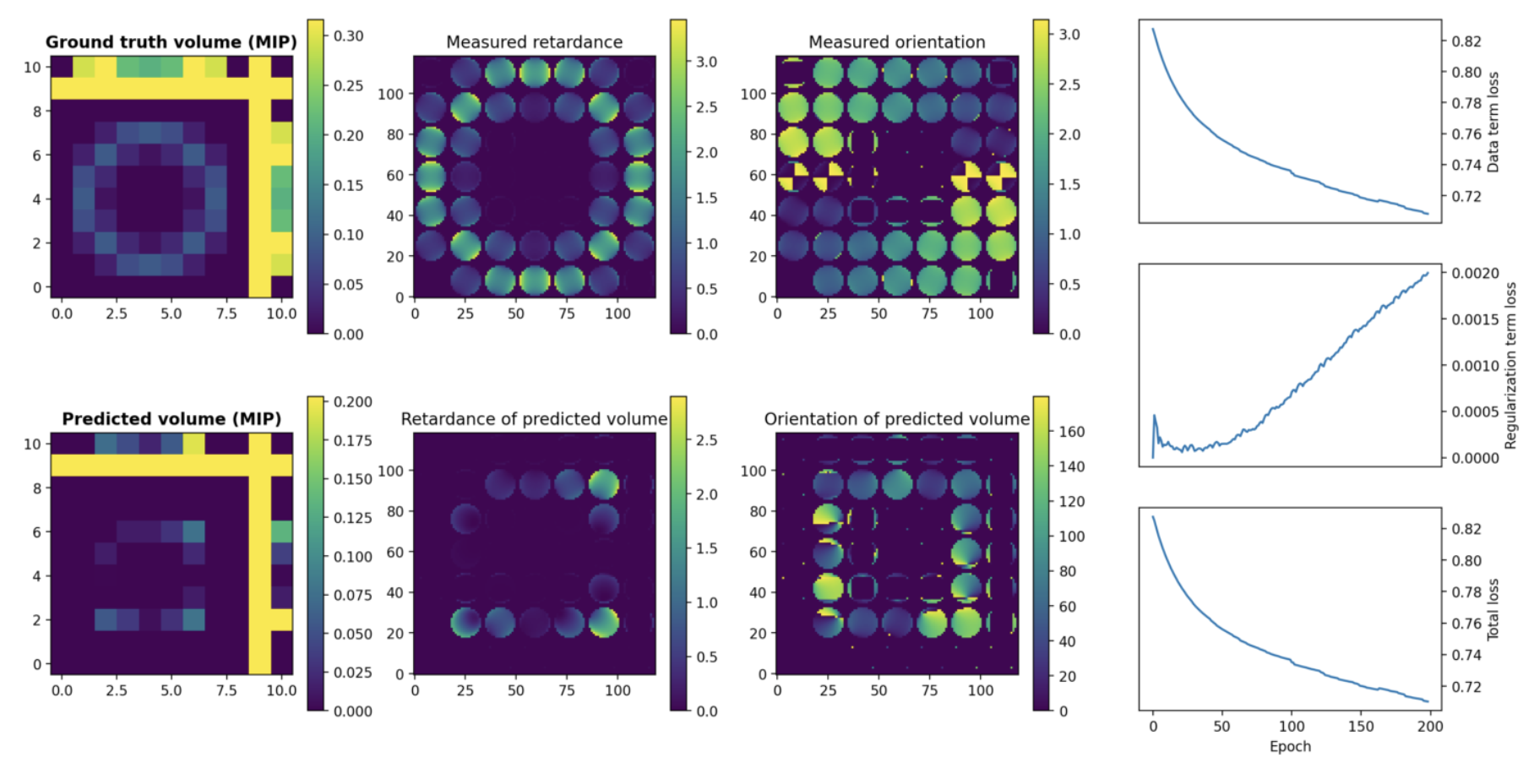

Where can you load the starting volume for the iterative reconstructions?

Make available optical parameters used for reconstruction.

**guv2_GT.h5 -> guvBir[radius=3.5, membrane thickness=1, Δn=-0.01]**

On July 12, negative birefringence values caused the following error message when attempting to plot volume with optic axis:

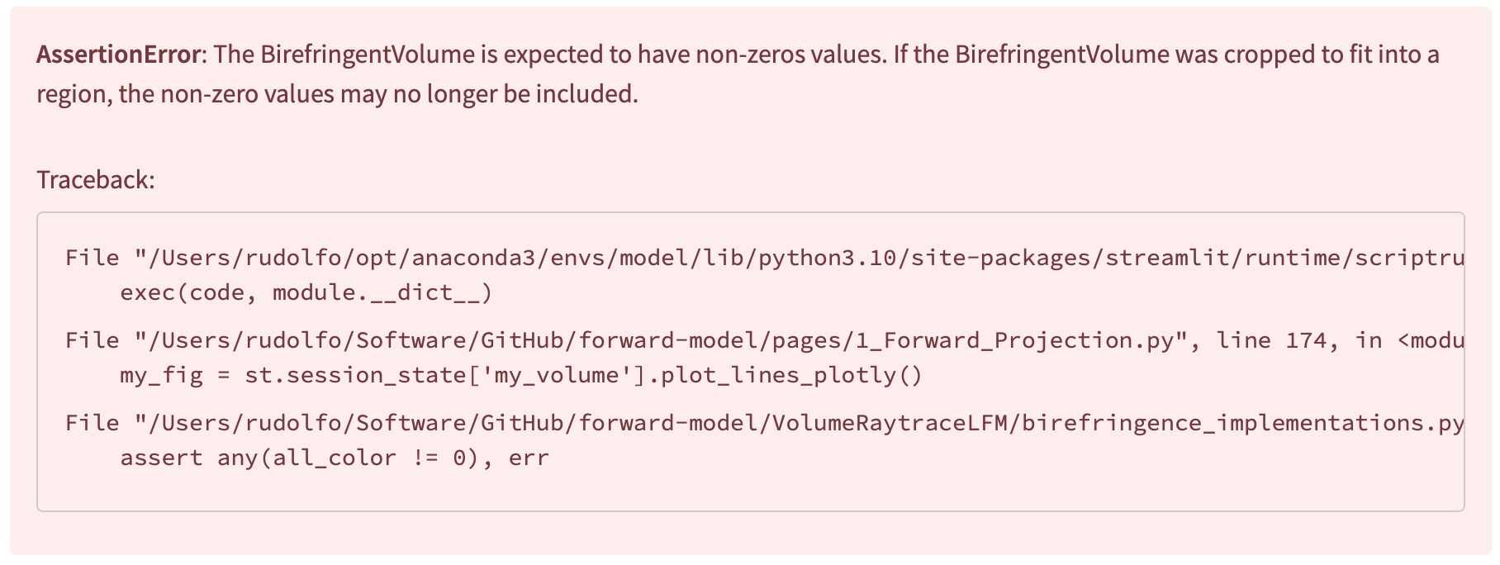

However, retardance and orientation images were calculated correctly.

Reconstruct guv1B.h5 (same object in larger volume):

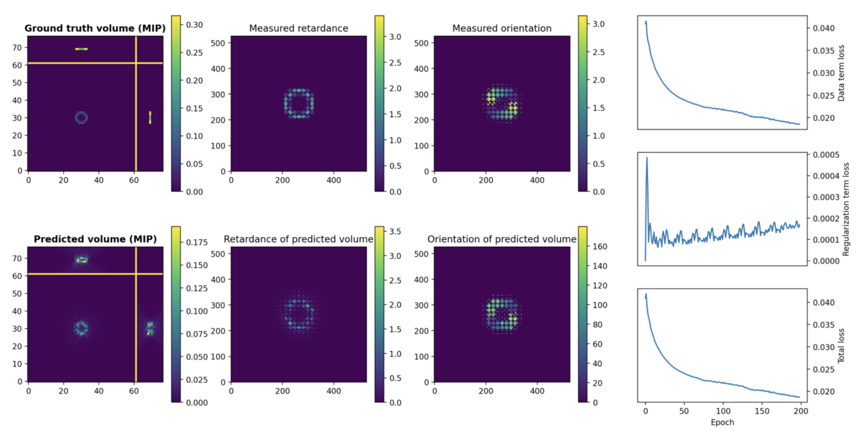

Volume also in file guv1B_Recon1.h5

**guv3_GT.h5 -> guvBir[radius=6.5, membrane thickness=1, Δn=0.01]**

Complete GUV

Number of microlenses: 31

Number of voxels per microlens (supersampling): 1

Volume shape: [15, 61, 61]

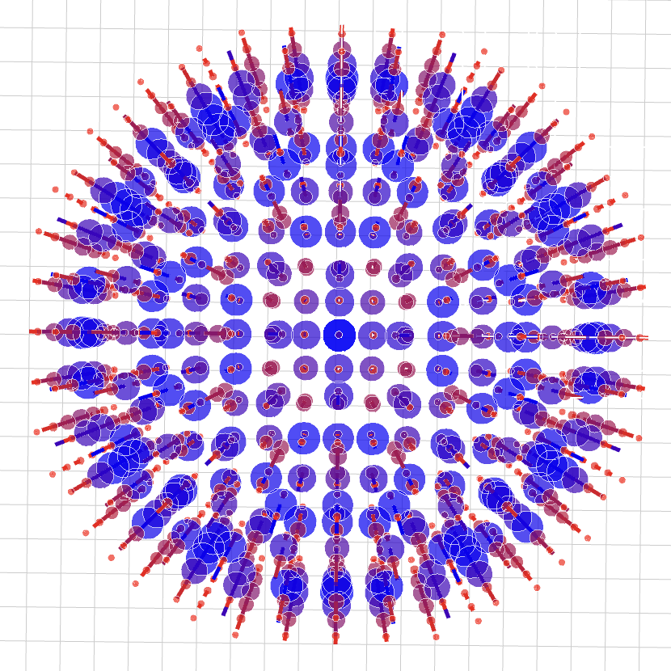 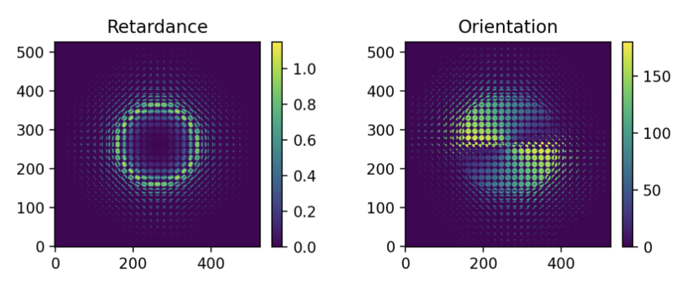

Reconstruction:

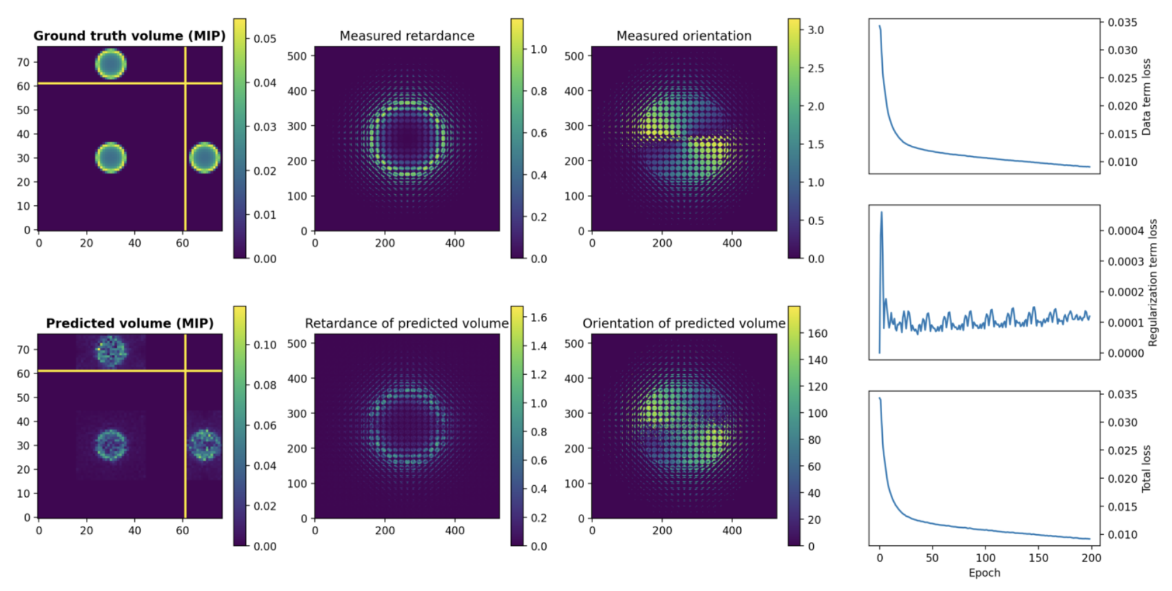

Volume also in file guv3_Recon1.h5

Number of microlenses: 11

Number of voxels per microlens (supersampling): 3

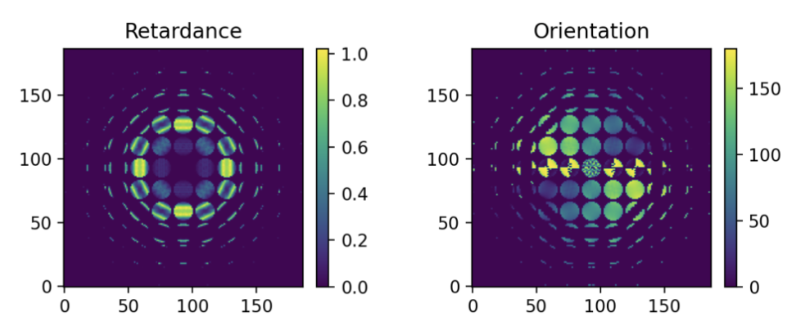

**Reconstruction in May:**

Iteration 0

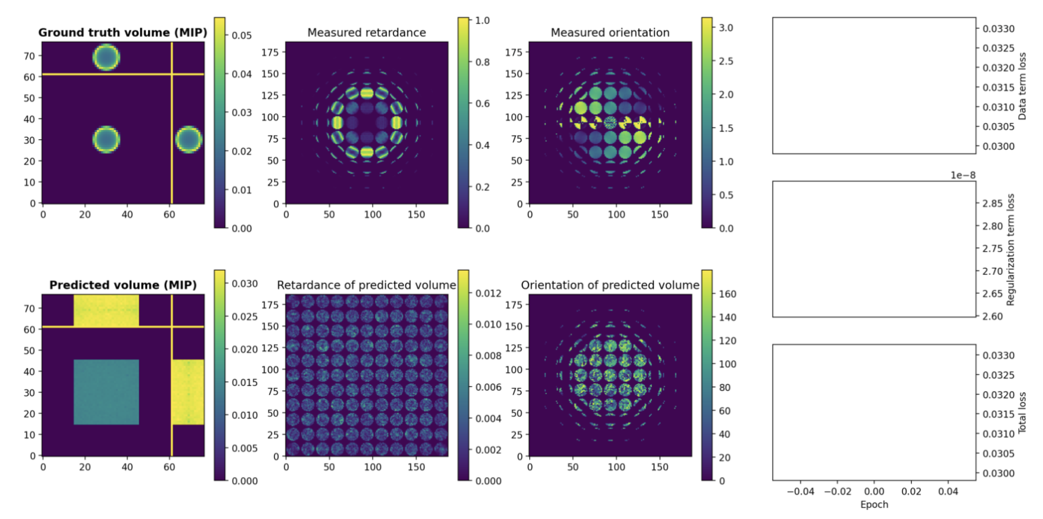

Iteration 4

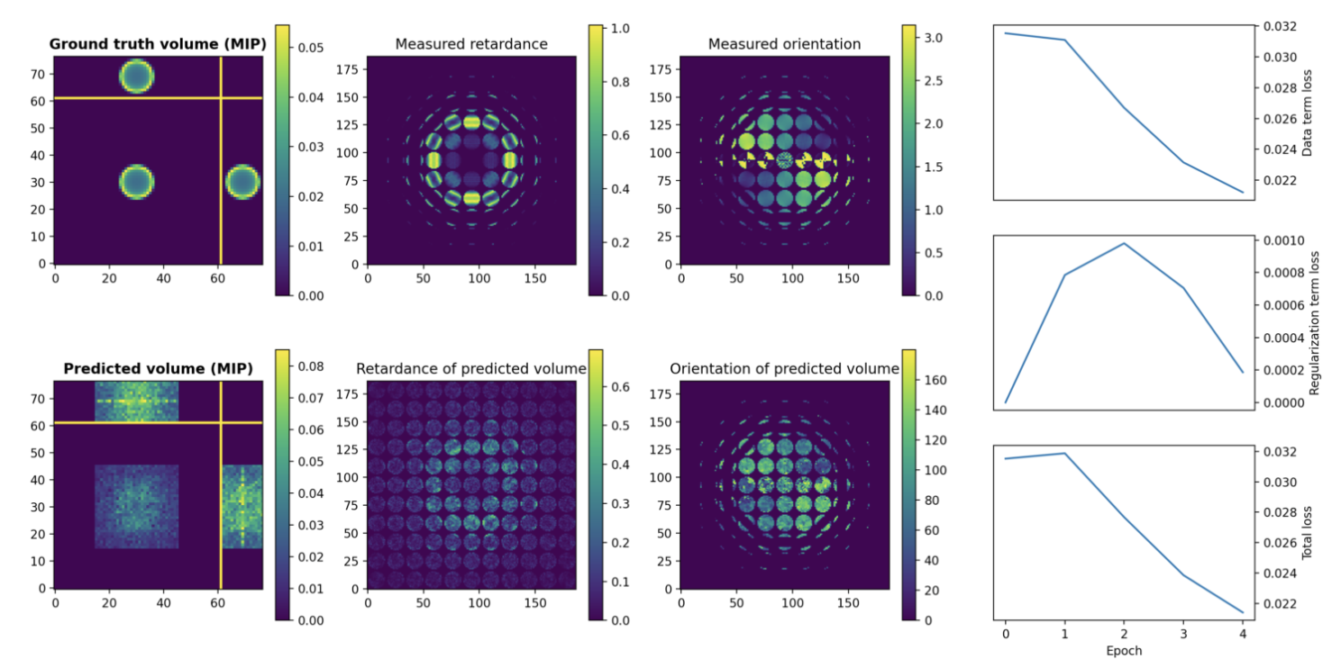

Iteration 50

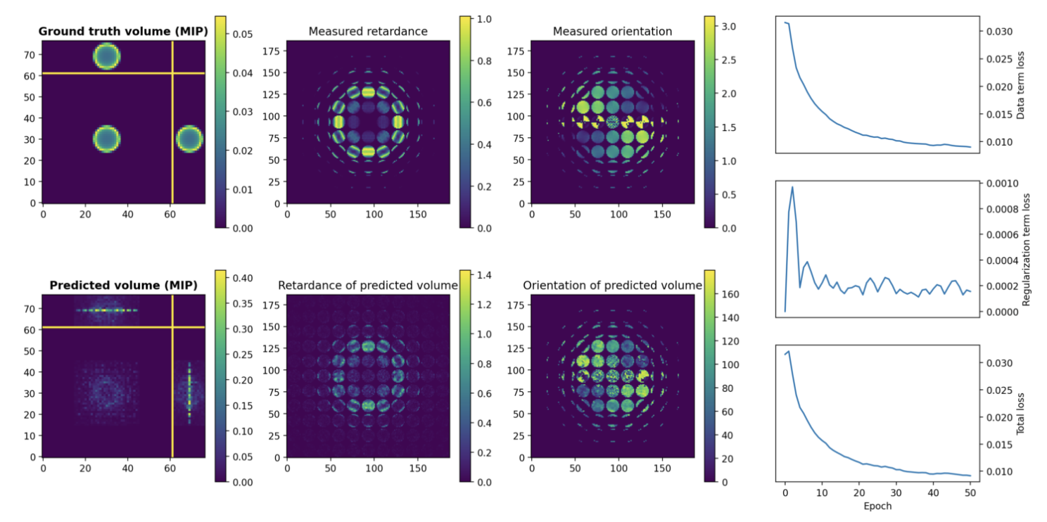

**Reconstruction in July:**

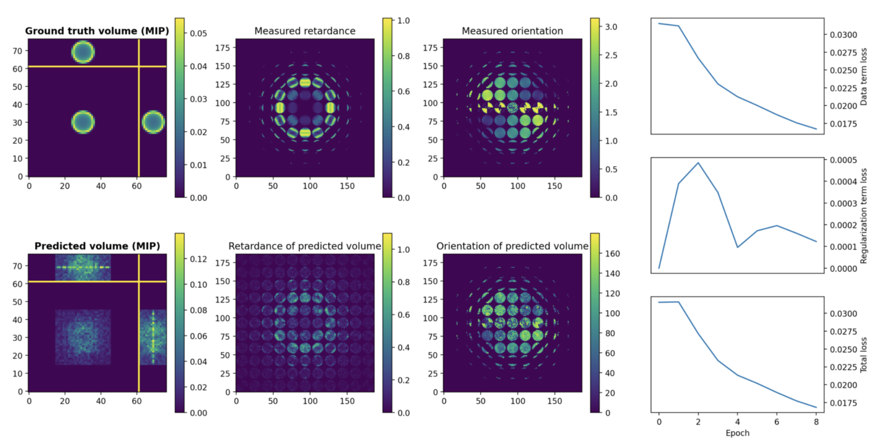

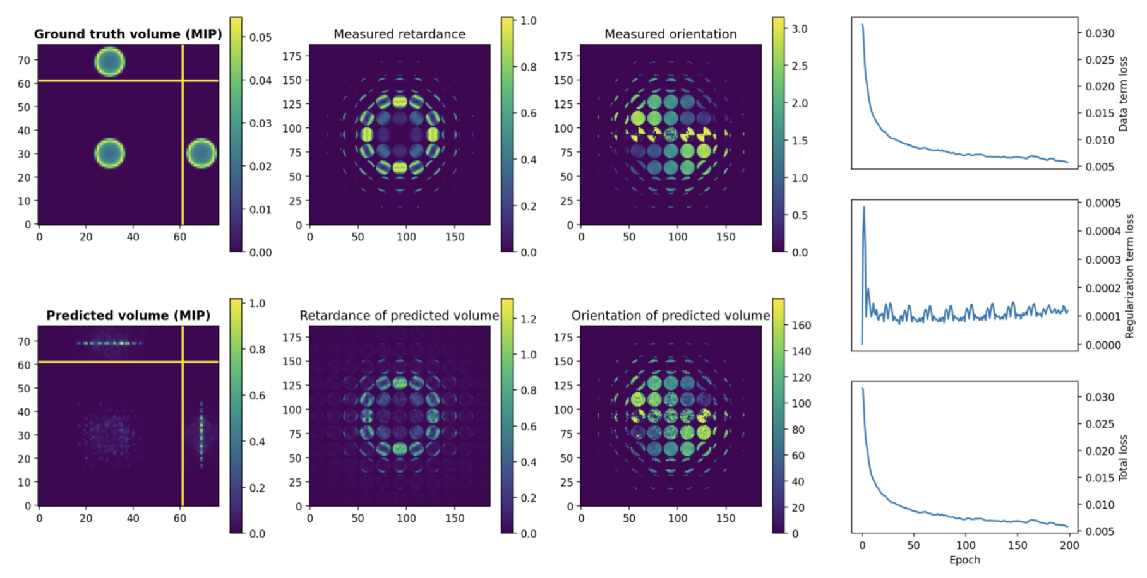

Volume also in file guv3_Recon2.h5

**guv4_GT.h5 -> guvBir[radius=9.5, membrane thickness=1, Δn=0.01]**

Number of microlenses: 17

Number of voxels per microlens (supersampling): 3

Volume shape: [23, 91, 91]

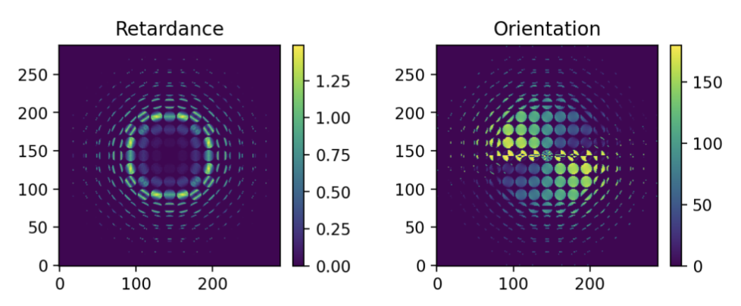

When forward projecting guv4_GT.h5 using the Mathematica Notebook PolRayTraceBirefrImagingJuly2023.nb, the maximum retardance is 0.29radian

**Reconstruction in July:**

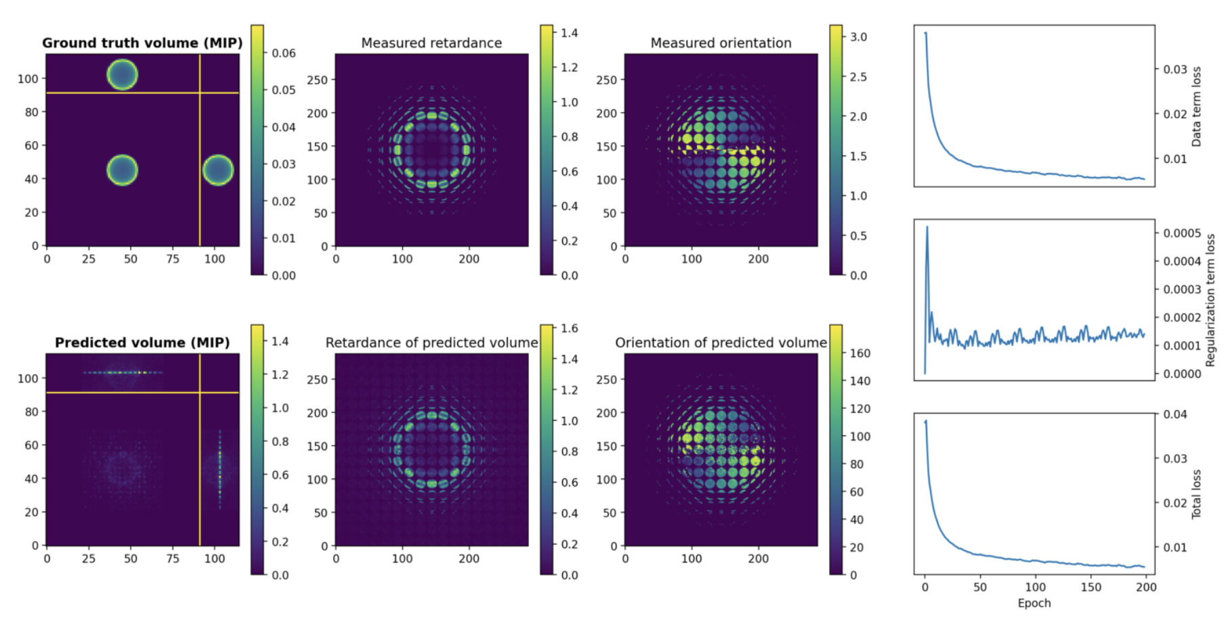

Volume also in file guv4_Recon1.h5

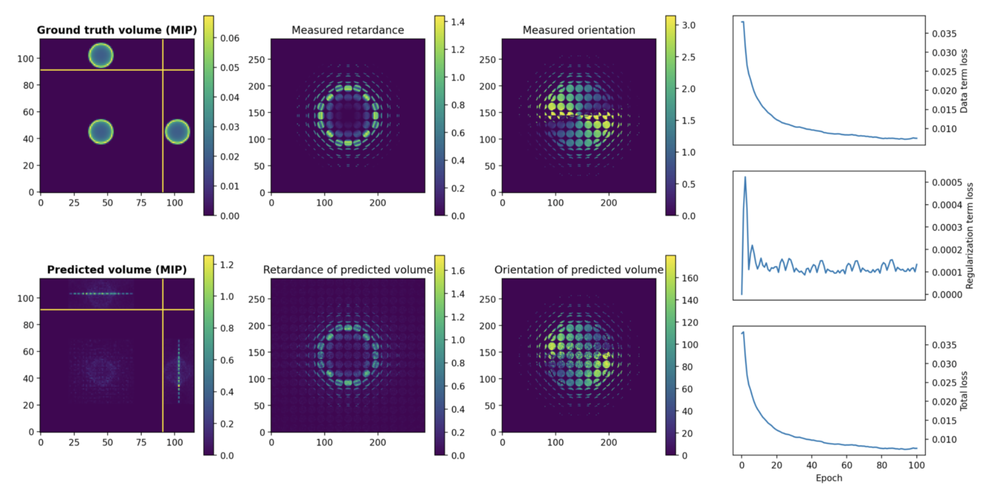

Volume also in file guv4_Recon2.h5